Controlled Substance Disposal Steps and Documentation
- Submit the DLD Inventory form to U-M Environment, Health, and Safety (EHS) at EHScontrolledsubstancedisposal@umich.edu.
Example:
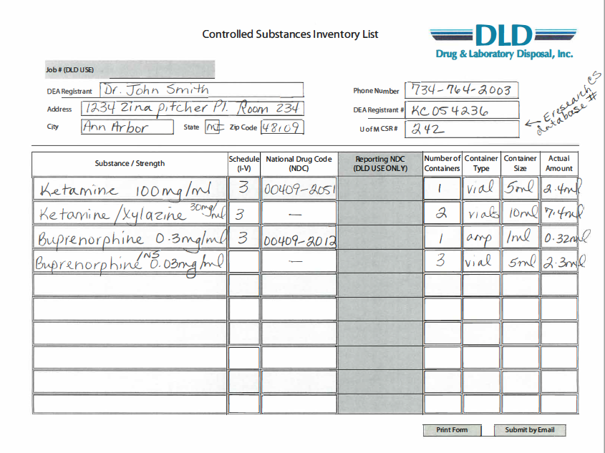
- Upon drug pick up by EHS and DLD, sign their provided chain of custody form. Look it over carefully to check for errors. Keep a copy of the form for your records.
Example:
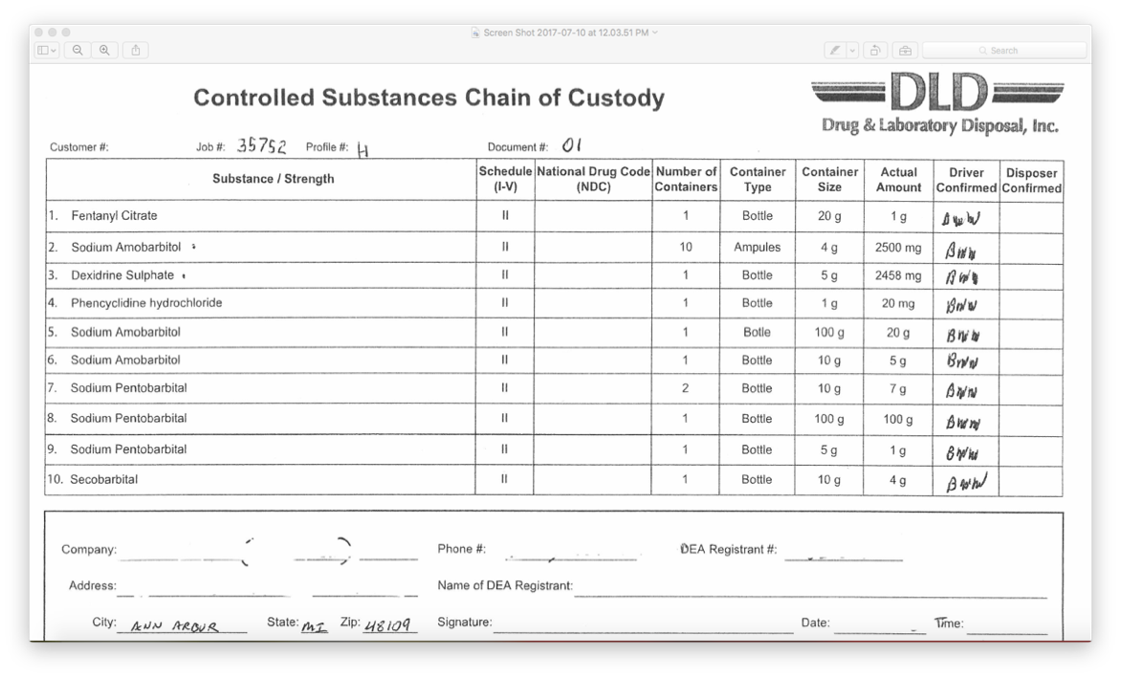
- Complete step 3 only if disposing of schedule I or II controlled substances. If not, skip to step 4.
Complete part #4 on DEA Form 222 (provided by DLD), labeled ‘To be filled in by supplier’. Make a copy for your records.
- To complete the disposal records, zero out the remaining balance and record disposal on the appropriate use log. See below for example:

Date | Amount  Used | Balance | Authorized Personnel Initials | Amount Wasted | Witness Initials | Amount Disposed  U-M  OSEH-DLD | Comments
3/2/15 | 5 ml | 1.5 ml | DP |  |  |  | Expired-waiting for p/u
3/10/15 |  | 0 ml | DP |  |  | 1.5 ml | DLD p/u

